Hampshire & Isle of Wight
Covid-19 Insight Report 19 March – 29 April 2020

At a glance
We have...

- Published dedicated coronavirus information and advice pages on our websites and have been signposting people to help them access services and community support
- Started asking our local voluntary and community groups to help be our ‘eyes and ears’ to hear people’s experiences of health and care services at this time
- Received comments predominantly about accessing GPs, pharmacies, community and carer support, and emergency dental services, as well as other services
- Shared and raised issues specifically around dentistry, pharmacy, maternity and cancer
- This report will be shared with the local NHS, Councils and providers so they can hear where things are working well, and help them identify any gaps.

Background
The way health and social care services operate has been affected by coronavirus (COVID-19) with non-urgent treatment postponed, face-
to-face appointments reduced and care homes and services limiting public access.

For local Healthwatch in Hampshire, Isle of Wight, Portsmouth and Southampton, the outbreak has also resulted in changes to our work, with much of our planned public engagement and visits to services paused and a greater focus on providing advice to the public and supporting the local response to COVID-19.

However, this does not mean that the work of Healthwatch to understand people’s experiences has stopped. With a fast-moving
COVID-19 response, real-time intelligence about the issues the public are facing is valuable. It is also important that services understand the impact these changes are having more broadly — especially when they concern people’s safety or will have implications for when services begin the return to normal.

Where is our insight coming from?
Due to the present circumstances we have had to adopt a flexible approach to engagement and many people continue to share their experiences with us via social media, through partner voluntary sector organisations, and by post, telephone, text or email.

We will also launch a survey so Hampshire and Isle of Wight residents can give feedback of their experiences of accessing health and care information, services and community support during this time.
In future this report will collate all these sources of insight.

Advice and information
Since the coronavirus outbreak, we have had a greater focus on our information and signposting service, to help people get the information they need from a trusted source.

We have created dedicated coronavirus advice and information pages which include all the latest national and local information and support. We also have created specific information in response to what we have heard from local people and groups. We have also been more active on social media, sharing information and asking for feedback on health and care services.
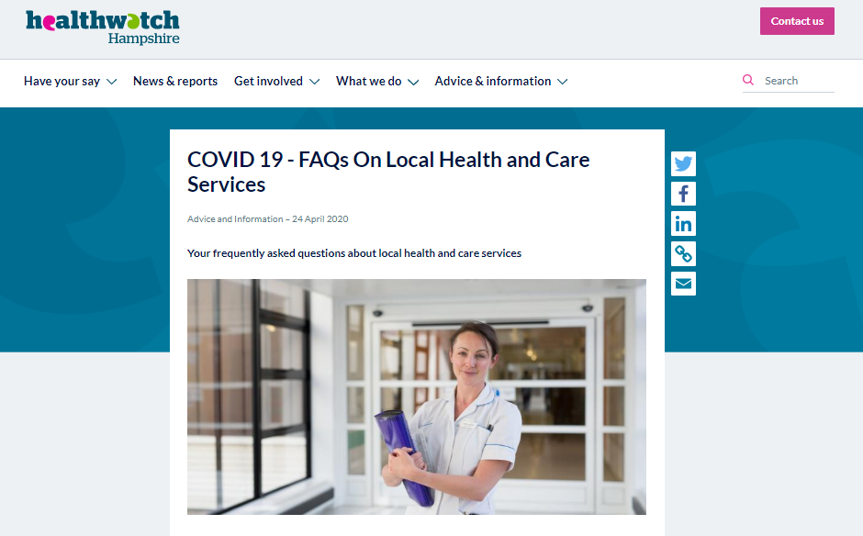

A summary of what are we hearing
Between the 19 March and the 29 April 2020 local Healthwatch received 159 comments about how Covid19 has impacted on health and care from across Hampshire and Isle of Wight. More than half the comments were collected by Healthwatch Isle of Wight.
The key services we have heard about are:
- GPs – both positive and negative (34)
- Pharmacies – predominantly about long waiting times, queues and access to medication (24)
- Community and Carer Support (20) – mainly asking advice as to where to get support for food and care
- Hospitals – both positive and negative (20) – predominantly about St Mary’s on the Isle of Wight and about travelling to mainland
- Emergency dental services (18) – how to access this for those in chronic dental pain
- Cancer (8) – again concerns about travel to mainland for treatment and increased likelihood of infection
- Ambulance and 111 (5) – 3 positive and 2 negative
- Post natal care (4) – women at home with new babies and other small children not having the usual support from services and families
- Council and other services.
The key cross-cutting issues and themes we are hearing about include:
- People are experiencing increased anxiety and stress at this time
- People need advice and signposting about how and whether to access other health and care services, particularly when people are shielding or vulnerable, and from people who are trying to support relatives who live on the Island from the mainland
- People need advice about access to community support, especially around food deliveries
- Care coordination is being negatively affected by current situation for some vulnerable people
- Personal Protective Equipment is difficult to access, particularly for care homes; it’s costing more; and there is confusion between services about its use in care homes
- End of life care

The rest of this report gives more detail and stories of people’s experiences on the top four areas of feedback; what we will do with this information; and how we intend to gather further insight.

GPs
Most of the feedback we have received to date has been linked to GPs, both positive about how surgeries are facilitating access to services, and negative. Several involved queries about whether it is still possible to get a GP appointment, prescriptions and hearing aid batteries. There is also confusion over the advice in ‘shielding letters’ and what people should be doing to protect themselves.
Concerns are also raised about changes to services that GPs would usually provide, such as blood/INR tests for Warfarin, B12 injections, and COPD checks, but that people feel are important to their well-being.
Individual’s mother is over 80. She has rheumatoid arthritis and is taking immunosuppressant medication so has been advised to shield. She received a telephone call from her GP practice asking her to go in for a blood test. She contacted her consultant for advice and he said that she must not go to the appointment as it is very important that she does not leave her home. She must shield.

Couldn't fault East Cowes surgery yesterday. Called them regarding a suspected ear infection for my young child, doctor called me back and I picked up antibiotics within an hour.
Excellent service considering the circumstances.

Pharmacies
Much of the feedback we have received to date has been linked to pharmacies and the collection of prescriptions, predominantly about long queues and wait times. This has been particularly difficult for older and more vulnerable people having to stand in the cold, as well as for those trying several times to collect prescriptions on the behalf of others. There was praise for the pharmacies who had efficient systems in place.
I had to collect my prescription last week from the Day Lewis pharmacy branch at Carisbrooke Health Centre. The queue was long mainly because we had to keep our distance, but it moved very quickly (it took me less than 20 min). Every so often, a member of staff was coming out and taking names of the 10 or so people in the queue, so when it was our turn, our bags were ready (mine had a 2-months supply which is very handy). I must say, I was very impressed with the work of this pharmacy - and this is not for the first time. They are very helpful and determined to provide exceptional customer care under any circumstances…
It's a very difficult situation. My relative and I are in isolation but we had someone queue up yesterday (at Boots, Ventnor) for 2 and half hours and they didn't get seen in time so someone else went back today and queued for another 2 and half hours and managed to get some of mum's prescription but the tablets that she has none of left, weren't in stock so she hasn't had any for two day now and no idea when she will get them. It is dangerous that people can't get their medication and that a lot of people can't queue for that long or get people to queue for them and even then you don't get seen but what else can be done? It's an impossible situation.

Community and Carers Support
People are generally getting in touch with Healthwatch and other organisations asking for help to find support around accessing food, medications and carer services. Some people were also offering help.
Hi my mum and dad live in X and are shielding - I live in Essex and I’m a nurse. I haven’t seen them since Xmas which is awful for us. They have wonderful neighbours who are looking after their shopping etc but I caught up with them on the phone tonight and they said a lady phones them every week checking on them that they have medication, food and are ok. Thank you, I presume it is volunteers and I think that is wonderful. Thanks to all …
My father who had a serious neck injury is now back home in X with Outreach Carers visiting. That Care ends on Sunday. Mum is still in a care home They would now like to both be back home together, having never been apart in 75 years So I need to find a care agency to provide visits. Any recommendations please?? I’m in isolation miles away in Surrey.
Caller contacted to ask if we were aware of any services in X who are dropping food to the elderly. I called a number of services and found X would be offering food delivery from next week. I have also contacted the local council who will look into this and see if there are any available. Caller hadn't completed the vulnerable person GOV.UK questionnaire to ask for support so we did this over the phone as she has no access to the internet. Caller will call X to register interest and I will call back with more information when I have a response from the council.

Hospital services
There are positive comments about how well people were cared for at St Mary’s despite the current situation. Others were concerned about travelling to hospitals on the mainland. There were a few negative stories about treatment via A&E or in more critical situations.
Individual has just had a call from their neurosurgeon, they have to be seen at Southampton general tomorrow for an emergency appointment. They have seen red jets are reduced and does not really want to be on a busy boat. They are unable to cancel appointment as they may need a procedure but is worried about how to get there safely.
Can I say a massive thank you to X hospital especially the doctor on tonight, in A and E. My 75 year old relative got took in an ambulance again today ... Broke ribs, just been to pick them up. Spoke to doctor on phone and at hospital. Even though they are obviously busy they gave me their time, patience, and understanding. Thank you.

I'm currently in A&E with my vulnerable child and the doctor has no clue what to do. He is currently asking his boss … My child has a long term health condition ... They now have a high temperature and are unwell … (I tried) 111 first and their advice was to go straight up and we would be seen immediately. We got here at 7:15pm and still here 3 hours later. They tested my child (for Covid) but hardly touched them with the swab. Nurse didn't know how to take swab and she kept looking at the instructions. I was told by 111 that we would be given masks to wear as soon as we got there. We were still in the main waiting room which was fast filling up and wasn't moved until I questioned them and when the nurse took observation no mask gloves or wiped down the equipment. I was shocked at the behaviour of the staff and lack of PPE.

What we will be doing next
To gather further insight about people’s experiences at this time we are:
- Increasing our monitoring of social media for relevant feedback
- Rolling out an ‘Eyes and ears’ approach, working with other community and voluntary organisations, to gather their feedback on people’s experiences
- Surveying people across Hampshire and Isle of Wight to better understand people’s access to information, support and services at this time
- Keeping a watching brief on other surveys and intelligence gathering that is being carried out e.g. on mental health issues, virtual appointments, from Black and minority ethnic communities etc.
We will also collate and share this insight with the local NHS, Councils and providers.
For help, advice and information

Healthwatch Hampshire
01962 440262 or enquiries@healthwatchhampshire.co.uk
www.healthwatchhampshire.co.uk

Healthwatch Isle of Wight
01983 608608 or enquiries@healthwatchisleofwight.co.uk
www.healthwatchisleofwight.co.uk

Healthwatch Portsmouth
023 9354 1510 or info@healthwatchportsmouth.co.uk
www.healthwatchportsmouth.co.uk

Healthwatch Southampton
02380 216 018 or healthwatch@southamptoncvs.org.uk
www.healthwatchsouthampton.co.uk
How this insight will be used
We recognise that all health and care services are under pressure at this time and have had to adapt their ways of working. We will share this report with the local NHS, Councils and providers to help them identify where things are working well and services are adapting to meet people’s needs, and to help them identify any gaps.

